Learn some overview of PHP and host WordPress website in Linux Ubuntu Machine with MySQL Database you can refer online blog ...you have to use Apache2 webserver

**To install Apache2 on Ubuntu, follow these steps:**

1. **Update the package index**: Open a terminal and run the following command to ensure your package list is up to date:

sudo apt update

1. **Install Apache2**: Use the following command to install Apache2:

sudo apt install apache2

1. **Start the Apache service**: After installation, you can start the Apache service with:

sudo systemctl start apache2

1. **Enable Apache to start on boot**: To ensure that Apache starts automatically at boot time, use:

sudo systemctl enable apache2

1. **Check the status of Apache**: You can check if Apache is running with:

sudo systemctl status apache2

1. **Allow HTTP and HTTPS through the firewall** (if you have UFW enabled): To allow web traffic, run:

sudo ufw allow 'Apache Full'

1. **Verify the installation**: Open a web browser and enter your server's IP address (or <http://localhost/> and “Public IP” if you're on the same machine). You should see the default Apache welcome page.

**Step 2: Install MySQL**

1. **Install MySQL Server**:

sudo apt install mysql-server

1. **Run the MySQL Secure Installation script**:

sudo mysql_secure_installation

**Follow the prompts**:

* **Set a root password**: If you have not set a password yet, you’ll be prompted to do so. If you already have one, you may skip this step.
* **Remove anonymous users**: It’s generally a good practice to remove anonymous user accounts.
* **Disallow root login remotely**: For security reasons, it’s advisable to restrict root access to the local machine.
* **Remove the test database**: The test database is often not needed and can be removed.
* **Reload privilege tables**: This will ensure that all changes are applied immediately.

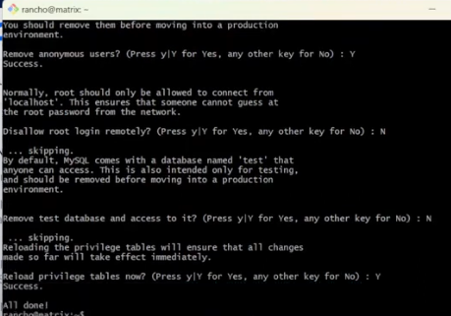

### **Step 4: Start MySQL Service**

Ensure that the MySQL service is running:

sudo systemctl start mysql

You can also enable it to start on boot:

sudo systemctl enable mysql

### **Step 5: Access MySQL**

To log into the MySQL shell, use:

sudo mysql

### **Step 6: Create a New User (Optional)**

If you want to create a new user and grant them privileges, run the following commands inside the MySQL shell:

CREATE USER 'newuser'@'localhost' IDENTIFIED BY 'password';

After that, create database

**1. Create Database**

CREATE DATABASE database_name;

Example: `CREATE DATABASE mydatabase;`

Replace newuser and password with your desired username and password.

### **Step 7: Exit MySQL**

To exit the MySQL shell, simply type:

EXIT;

### **Install PHP**

To install PHP and the necessary extensions for MySQL, run:

sudo apt install php libapache2-mod-php php-mysql

### **Step 4: Restart Apache**

After installing PHP, restart Apache to enable the PHP module:

sudo systemctl restart apache2

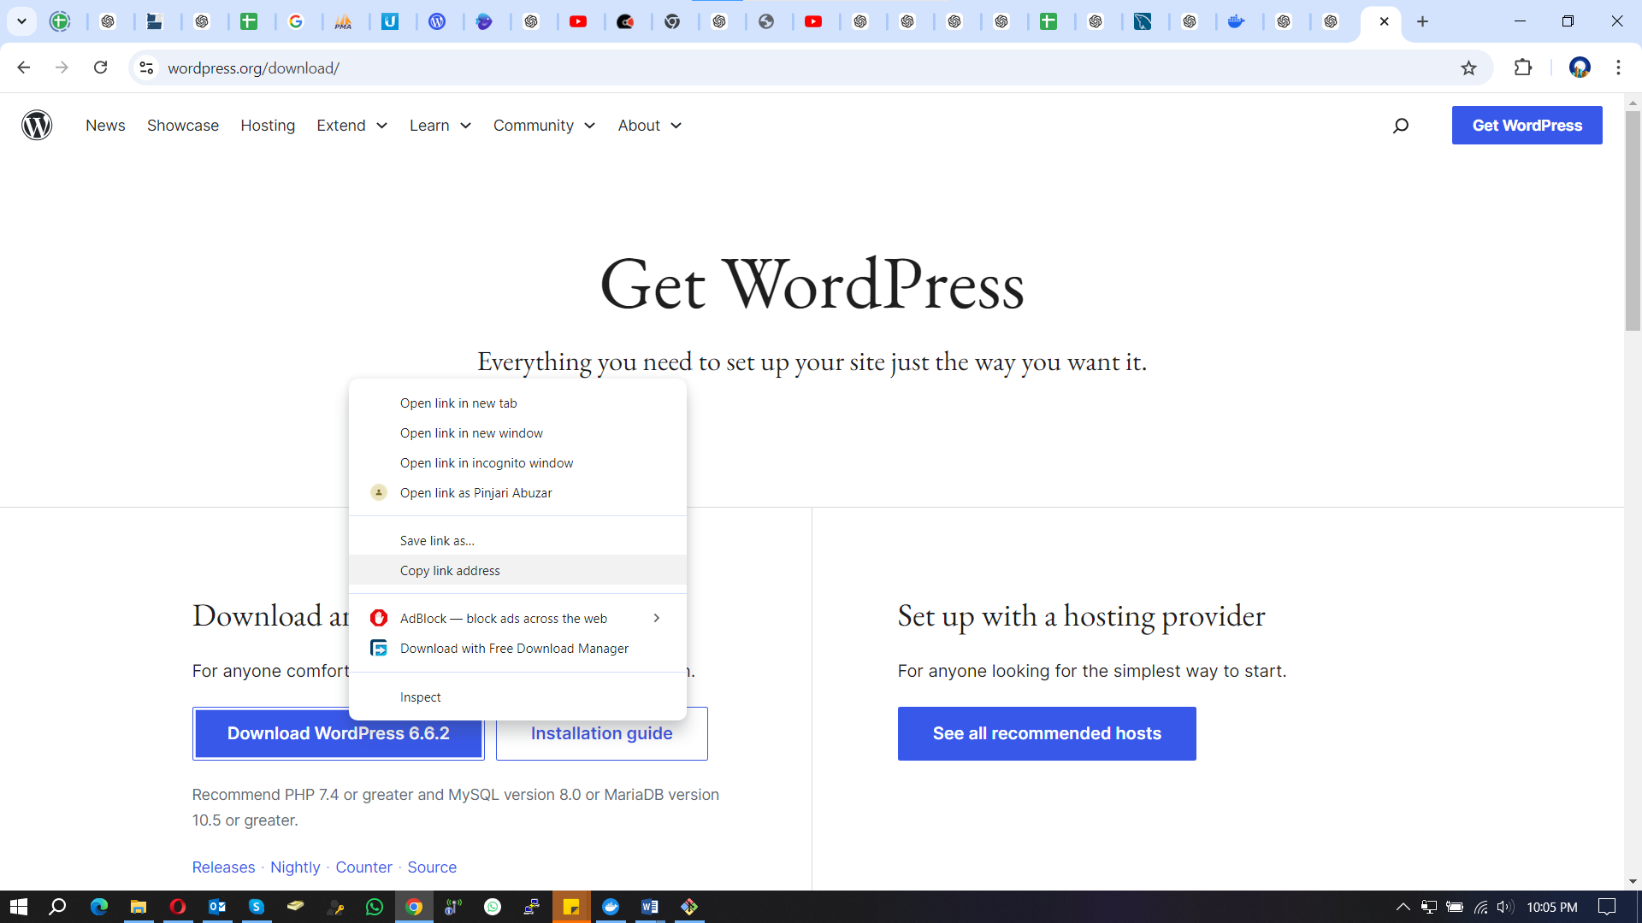

Copy the link and down WordPress in Ubuntu

sudo wget <https://wordpress.org/latest.zip>

For Download, unzip package

sudo apt install unzip

If you want to unzip to a specific directory, use:

unzip yourfile.zip -d /var/www/html

You can login into WordPress

